PSP0201
Week 3 Writeup

Group name: SOLO
ID | NAME | ROLE
1211100574 | Ivan Liew Qi Hong | leader

Day 6: [Web Exploitation] Be Careful With What You Wish On Christmas Night
Tools used: Kali Linux, Firefox, OWASP Zap
Solution/Walkthrough:
Question 1
Check OWASP cheat sheet for answer

Question 2
Copy expression from OWASP cheat sheet

Question 3
The answer can be found by reading the text

Question 4
Typing anything in the query will add the query string q which can be abused
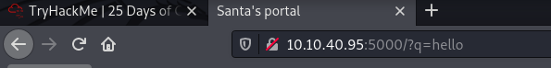

Question 5
The XSS alerts of hight priority are found in the alerts tab after running the attack which are indicated by the red flag
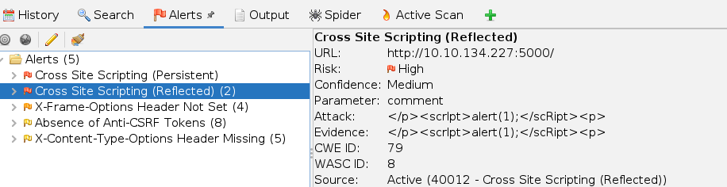

Question 6

Question 7
Closing and reopening the browser, the attack still persists
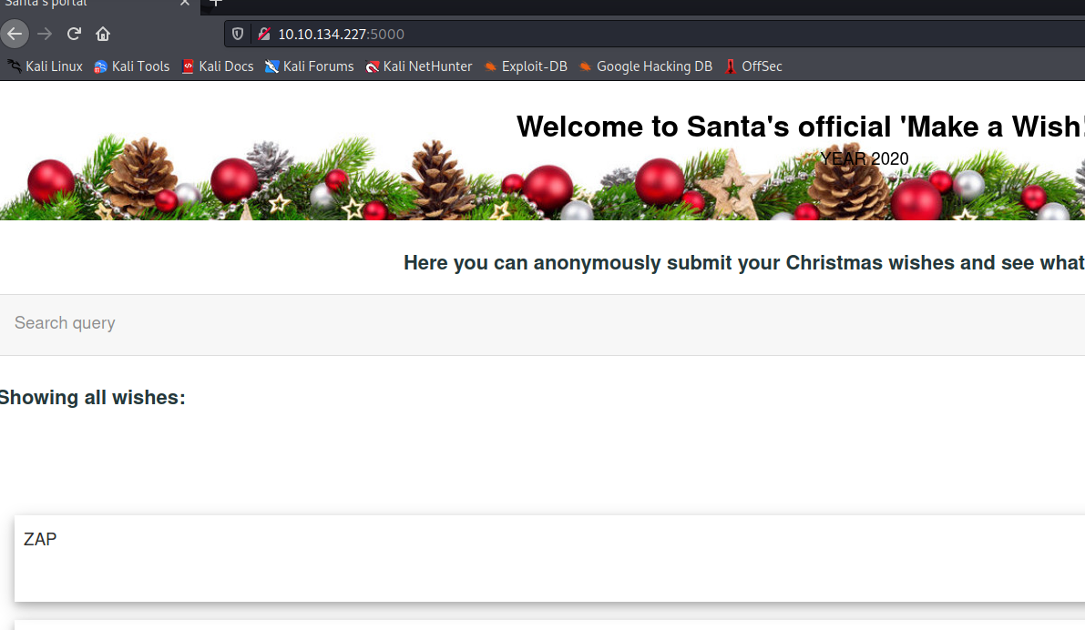

Thought Process/Methodology:
I placed the URL of the website into OWASP Zap and proceeded to attack it. It then showed the alerts that it had acquired.

Day 7: [Networking] The Grinch Really Did Steal Christmas
Tools used: Kali Linux, Firefox, Wireshark
Solution/Walkthrough:
Question 1
The Ip address can be found by looking at wireshark after the file has been open
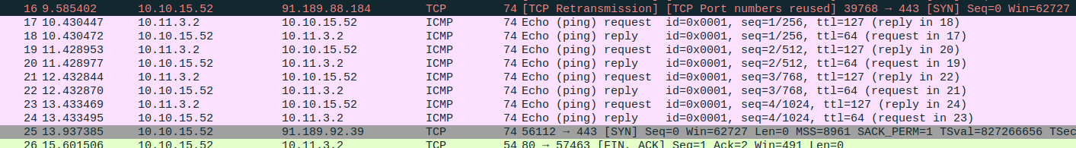

Question 2
The filter is http.request.method == GET

Question 3
The name of the article can be found after applying the filter
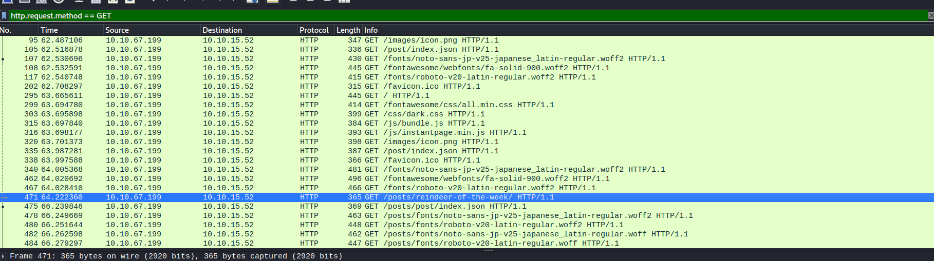

Question 4
Follow the successful login to find leaked password
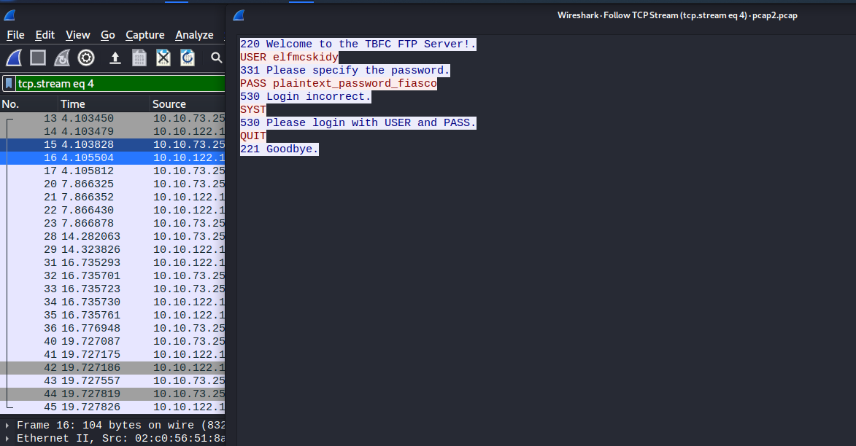

Question 5
The encrypted protocol can be found at the top

Question 6
Find the arp communication under protocols

Question 7
Go to http protocol and follow it. It then shows that there is a zip file which can be exported
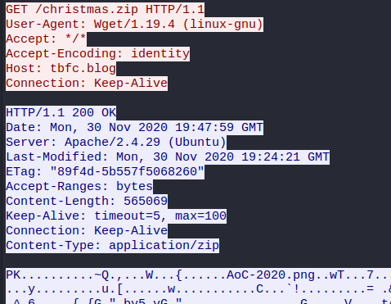
Extract file and open Elf McSkidy’s wish list
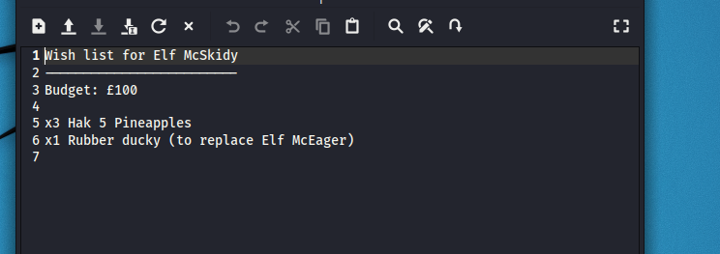

Question 8
Open operation arctic storm pdf and find author
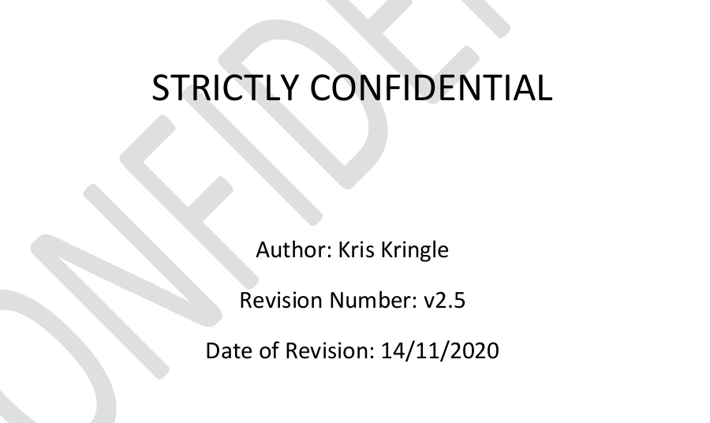

Thought Process/Methodology:
I opened Wireshark and open each of the files. In pcap1.pcap, I filtered to get the name of the article. In pcap2.pcap, I used a tcp port filter to get the password by following one of the ones that have a successful login. I then found the arp protocol which held a conversation. In pcap3.pcap I found a Http with a zip file which I exported and downloaded with the wish list as well as the operation storm pdf.

Day 8: [Networking] What’s Under The Christmas Tree
Tools used: Kali Linux, Firefox,
Solution/Walkthrough:
Question 1
Check the internet

Question 2
Put nmap and ip addres in terminal to get ports
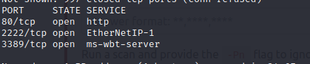

Question 3
Put nmap -A Ip address to get answer
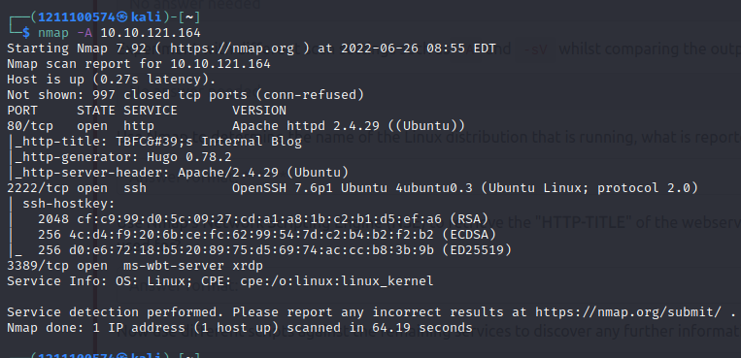

Question 4
Apache version can also be found in the same command
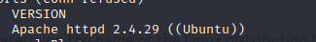

Question 5
Port 2222 can also be found in the same command
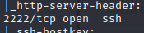

Question 6
Title is also in the command
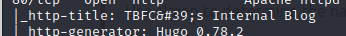

Thought Process/Methodology:
I entered the nmap command along with the Ip address to get the ports. I then used the nmap command with -A to get information such as distribution, Apache version, what a port is running and the title.

Day 9: [Networking] Anyone Can Be Santa!
Tools used: Kali Linux, Firefox,
Solution/Walkthrough:
Question 1
Using command ls, all available directories are shown
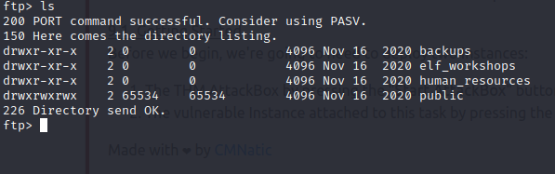

Question 2
Only 1 is shown to has data so it is assumed that the others are currently inaccessible

Question 3
The script can be found after navigating to the public directory and using the ls command again
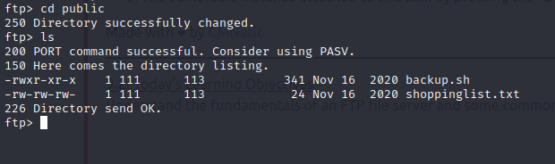

Question 4
Use get to retrieve the text file to find the movie
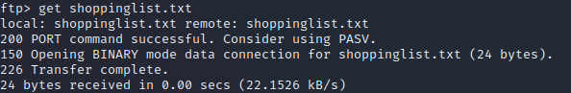
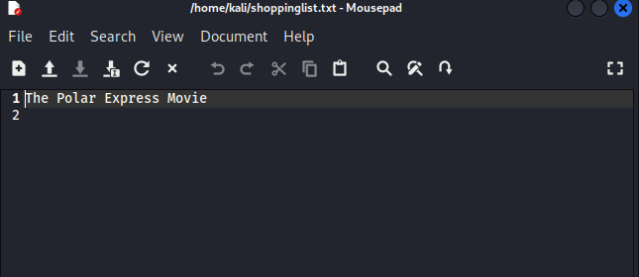

Question 5
Open the shell script with a text editor. Return back to ftp and put shell back into public directory.
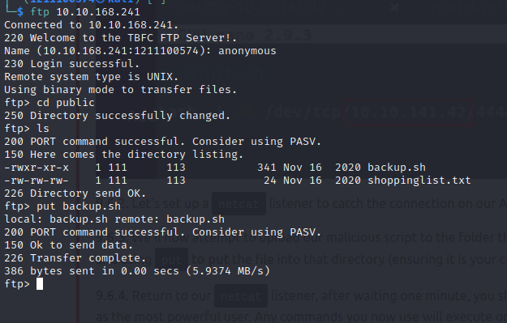
Get root flag from rootflag.txt

Thought Process/Methodology:
Using FTP commands, I logged in and found files that I have access and no access to. I got the shell script and text file which I then used. I then modified the script with malicious code and put it back. I then netcat the port and got the flag from the text file.

Day 10: [Networking] Don’t Be sELFish!
Tools used: Kali Linux, Firefox,
Solution/Walkthrough:
Question 1
Use help options to find correct descriptions

Question 2
Use -U command with Ip address to find number of users on Samba server
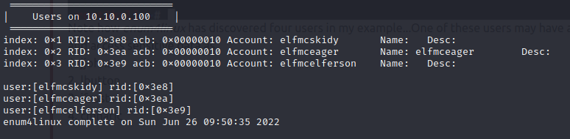

Question 3
Use -S command to find shares
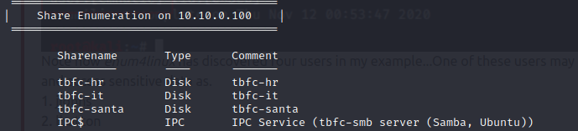

Question 4
Trying no password on the shares until 1 gave access
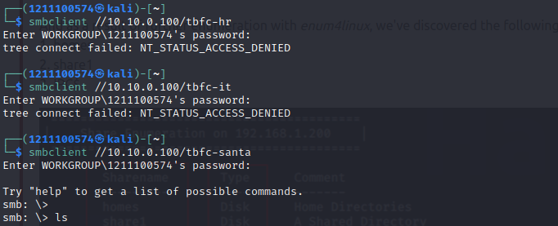

Question 5
Use ls to find directories and get the text file from mcskidy
